Integrate and Fire neuron spiking update

Went back into the code to tweak values and ensure we are getting an output that makes sense without any electrical stimulation. As a reminder this I&F model utilizes E-E (excitatory onto excitatory) and E-I (Inhibitory onto excitatory) synaptic weights but not I-E or I-I. These values were previously calculated using values from Holmgren et al 2003, **Pyramidal cell communication within local networks in layer 2/3 of rat neocortex**.

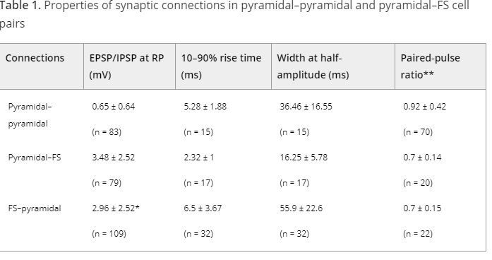

We are also using values from neuroelectro.org

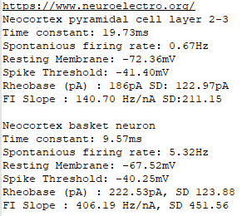

As an example interaction, a single E-E connection will increase the resting potential of the pyramidal neuron from -72.36mV to -71.71. 46 firings will result in depolarization of the pyramidal neuron. Since we are using a probabilistic model, this is translated to roughly 1/42 = 0.0238 probability increase. Synaptic weight decays over time with a 9ms decay constant.

**Plots without any electrical stimulation:**

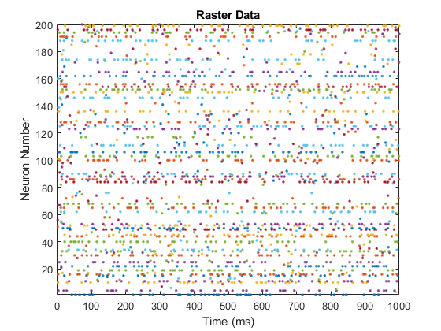



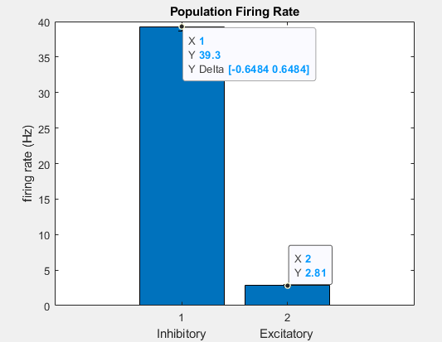

**Notable difference between this model and our model:** This test model may have multiple inhibitory neurons acting on one excitatory, whereas our model has a single set E-I connection for every excitatory neuron.

**Reference neuron activity when no E-I synaptic weights are considered:**



**Data From our model – No stimulation**

2500 neurons, 4/24 same pad connectivity





**Data From our model – With stimulation**



